**LAB ASSIGNMENT- 6.4**

**ROLL_NO:2403A52349**

**NAME:TAHIYA MAHEROZE**

**TASK1:**

**write a python program with class named student with attributes name,roll_num,and marks using functions display_details() and is_passed() and also ask the user input**

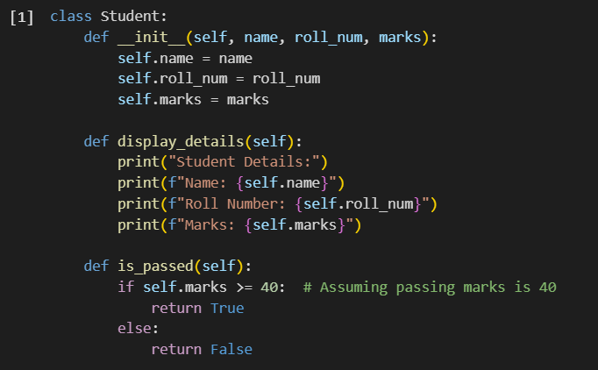

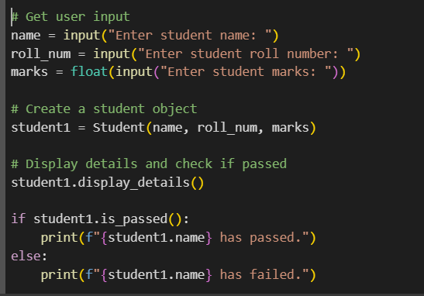

**OUTPUT:**

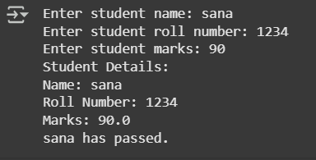

**EXPLANATION:**

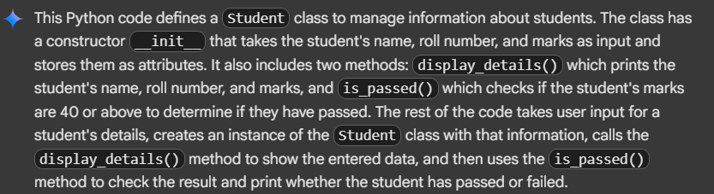

**TASK2:**

**write a python program to write first 2 lines of a for loop to iterate through a list of numbers with conditional logic if number%2==0 using functions**

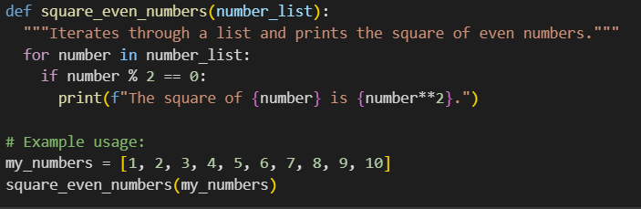

**OUTPUT:**

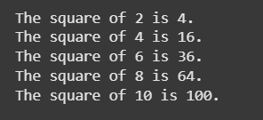

**EXPLANATION:**

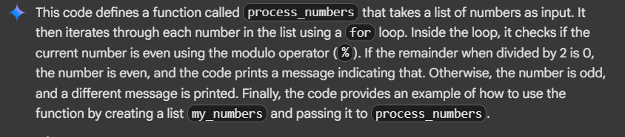

**Task3:**

**write a python program to create a class called bankaccount with attributes account_holder and balance using deposit(), withdraw(), and check for insufficient balance and also Code should prevent overdrawing.**

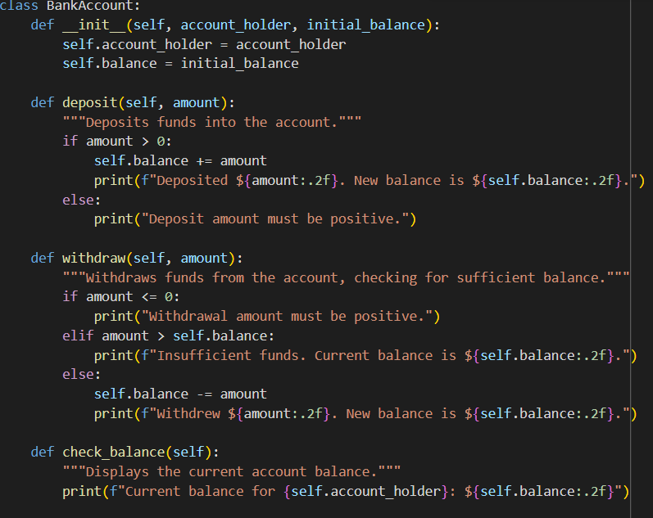

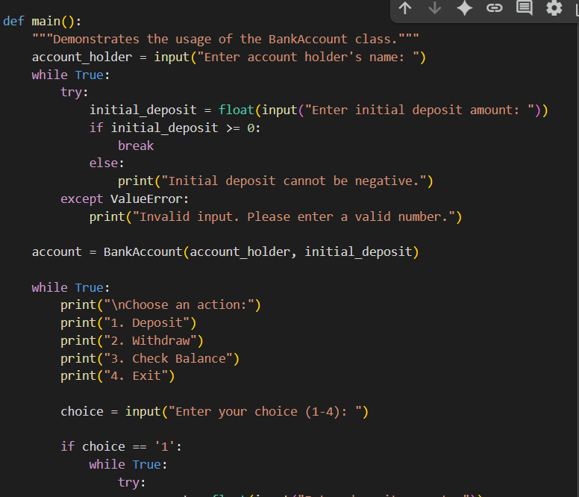

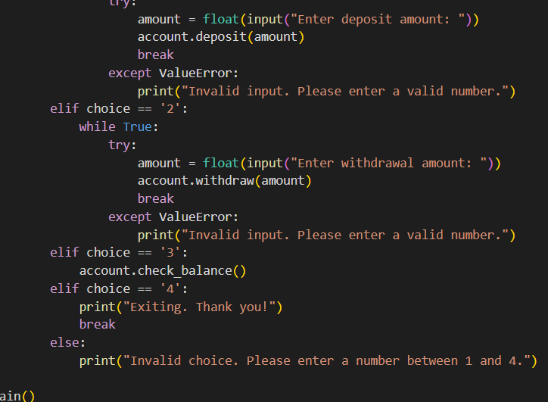

**Output:**

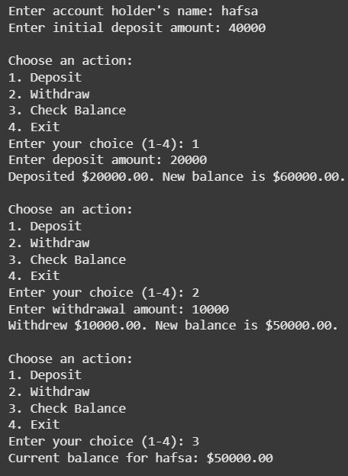

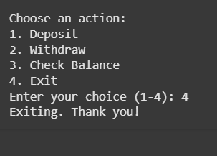

**Explaination:**

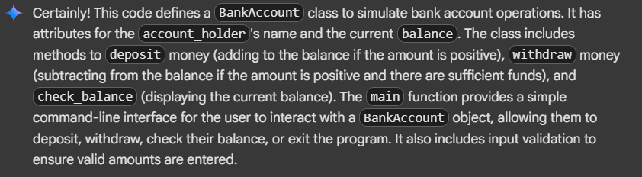

**Task4:**

**write a python program to define a list of student dictionaries with keys name and score with while loop to print names of the students who scored more than 75 and ask the user input using functions**

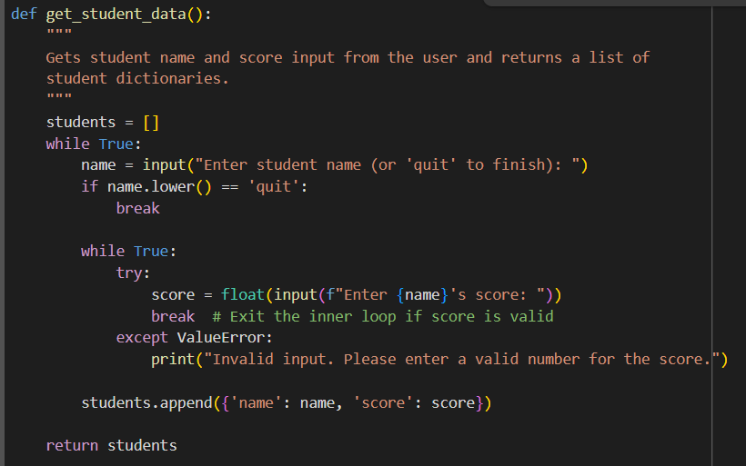

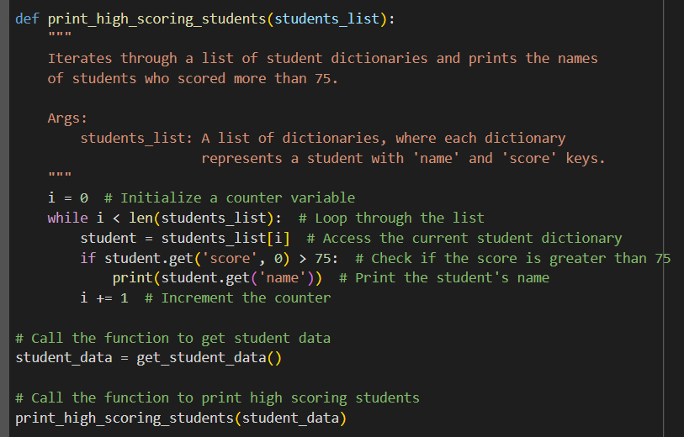

**Output:**

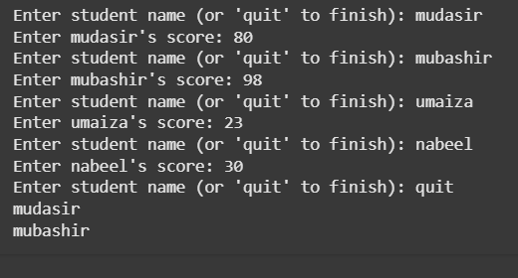

**Explaination:**

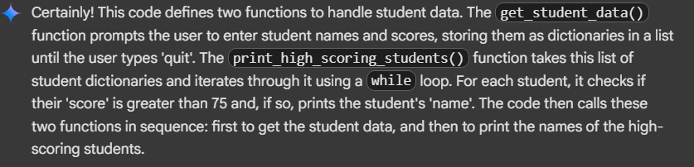

**Task5:**

**write a python program that writes class shoppingcart with an empty items list generate methods to add_item,remove_item,and use a loop to calculate the total bill using conditional discount using functions**

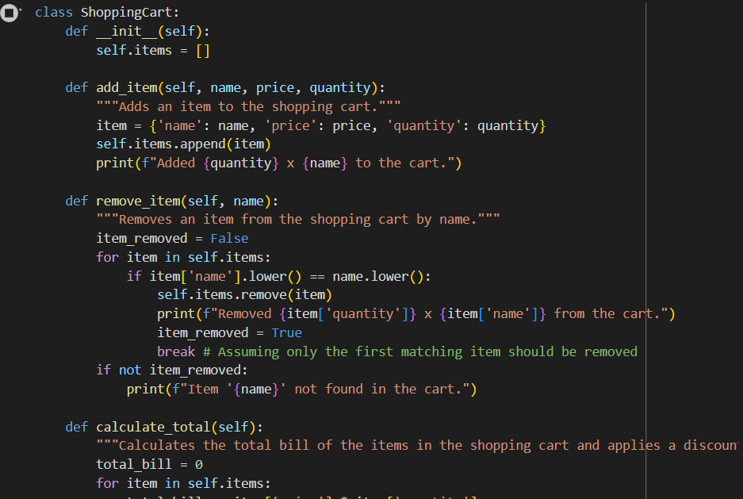

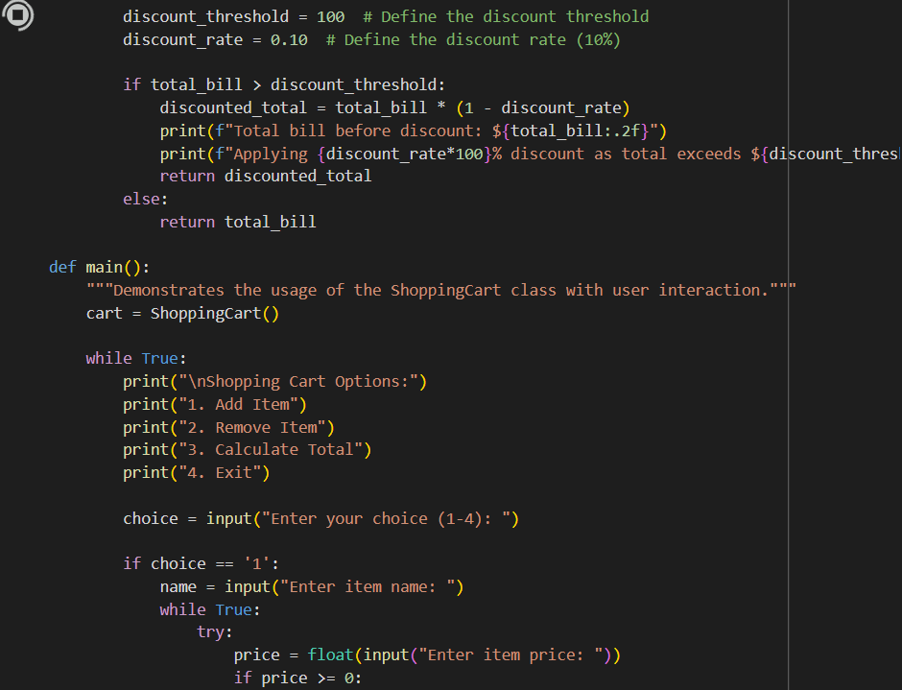

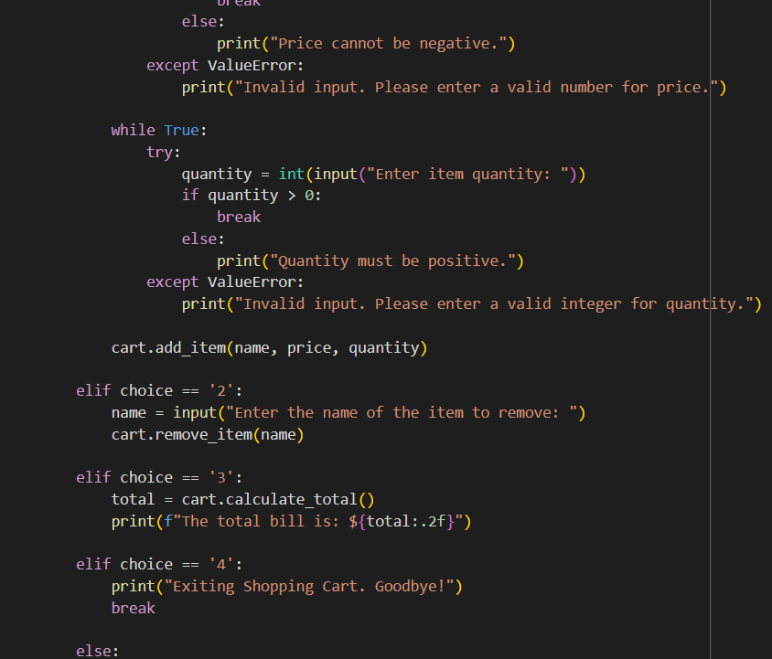

**Output:**

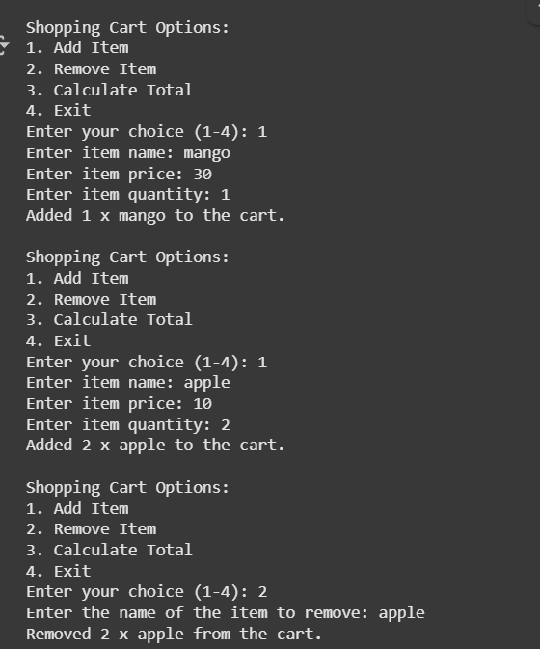

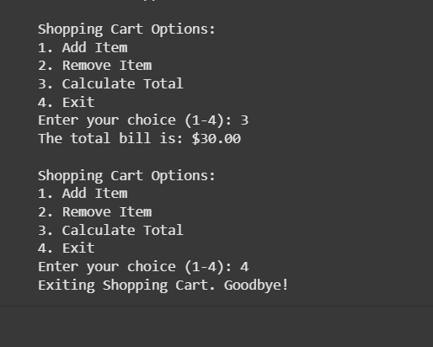

**Explaination:**

